Hello Othermill Pro User,

We have recently discovered that a limited number of Othermill Pro mills were assembled with a batch of Y-axis and X-axis linear bearings that contained less PTFE lubricant than intended. All Othermill Pro mills have passed our factory tests for proper operation, but this material issue may cause carriage binding issues to develop over time.

Your machine is included in the group that has these bearings. In some cases these bearings can cause excessive friction in the axis, which can result in loss of position and the mill cutting in the wrong location.

Although not all mills with these bearings experience any problems, we are sending out PTFE wipes that should be applied to the rails (the metal rods that hold up the carriage) in the Y-axis and X-axis. In machines exhibiting issues, our testing shows that applying these PTFE wipes to the rails rectifies the issue in most cases. We apologize that this error occurred and for the time and hassle involved on your end.

Included in this envelope are PTFE wipes. Here’s how to use them.

**1. Check For and Remove Debris:**

Focusing on the Y-Axis and X-Axis, it is important to give the mill a good vacuuming and clean off the rails well ***before*** applying PTFE to the rails.

When vacuuming, focus on the rails, and the lead screw. Using a small brush and a vacuum is helpful.

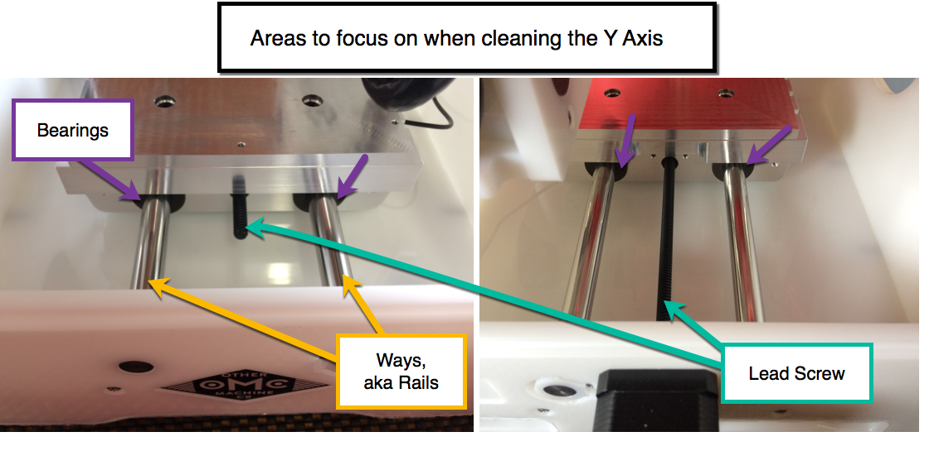

If you have access to compressed air, aim it into the small space between the rails and the bearing. Do this for the four Y-Axis and four X-Axis bearings.

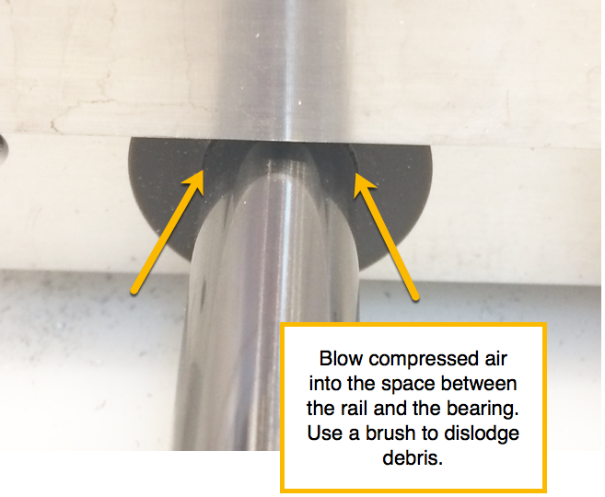

If there is any debris still stuck to the rails, use a lint-free wipes and 91% isopropyl alcohol to clean them. This should be done ***before*** applying the PTFE wipes.

**2. Apply the PTFE wipes onto the rails**

* Move the Y-bed to the back of the mill. Take the PTFE wipe and wipe along the rails, making sure to cover all sides of the rails up to where the rails meet the linear bearings.
* Move the Y-bed to the *front* of the mill. Apply PTFE in the same manner as in step 2.
* Move the X-Carriage to the right side of the mill, and apply PTFE wipes to the rails.
* Move the X-Carriage to the left side of the mill, and apply PTFE wipes to the rails.
* The wipes consist of PTFE suspended in isopropyl alcohol and ethanol, so it is a generally safe material. ***However, the manufacturer recommends using gloves when applying the PTFE.***

The PTFE is now applied to the rails, but now we want to spread it around evenly. To do that, please follow these instructions.

* ***Remove any end mill or probe from the spindle***
* In Otherplan or the Bantam Tools Desktop Milling Machine Software click on "home" or "re-home"
* Open Debug Console (Bitbreaker > Show Debug Console)
* Download [this file](https://www.dropbox.com/s/yt0pgd4oq69t24y/Way%20Bearing%20Breakin%20100%20x%20distance%20lost.TXT?dl=0). (Do not copy and paste from the browser, as sometimes this truncates the code.)
* Copy everything from the file you downloaded, then paste it into the Debug Console
* Click "Send Command"
* Wait 12-15 minutes for the machine to run the code, and you’re done!

These PTFE wipes are suspended in 91% isopropyl alcohol and ethanol. Please do not use PTFE wipes that are suspended in other substances, as they can cause issues. Also, please keep unused wipes in a sealed bag or container to prevent them from drying out.

We expect one application of PTFE every six months to be sufficient to avoid binding issues. Under heavy usage this interval should be reduced. We are happy to provide additional PTFE wipes at no cost, or you can purchase them [here](http://shop.2xlcorp.com/all-wipes/Teflon-Lubricating-Wipes.html). To request additional wipes, or let us know if you have any other questions, email us at support@bantamtools.com.

Best regards,

-The Bantam Tools Support Team